FLORAL INTERPRETATIONS OF MEMORIAL-THEMED ART
Grade 8 Visual Art Students at Tantasqua Regional Junior High School

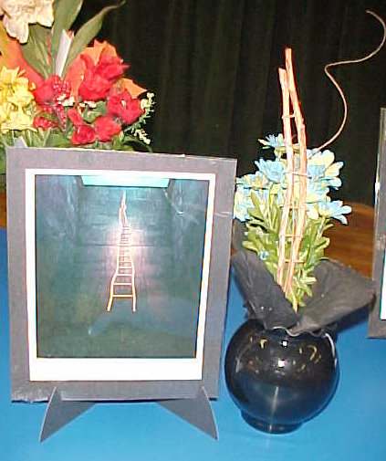
Ladder for Booker T Washington by Martin Puryear

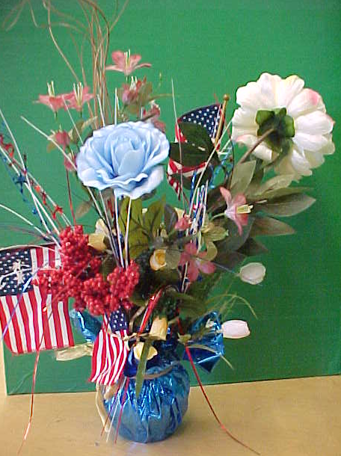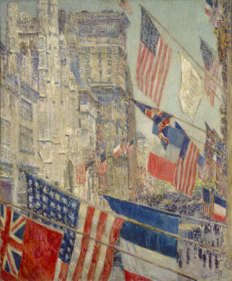
Allies Day May 1917 by Childe Hassam

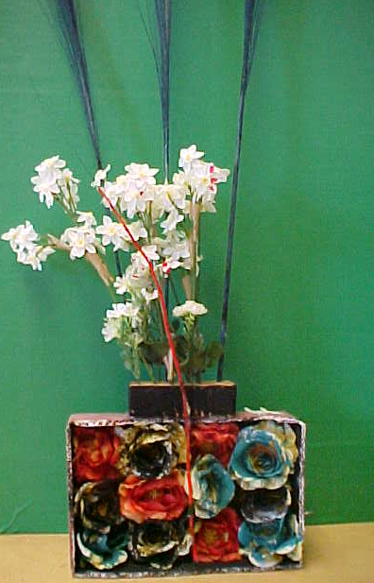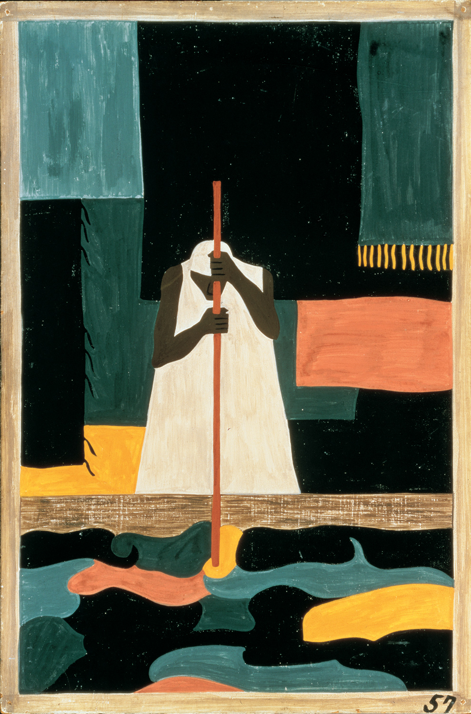
The Migration Series #57 by Jacob Lawrence

